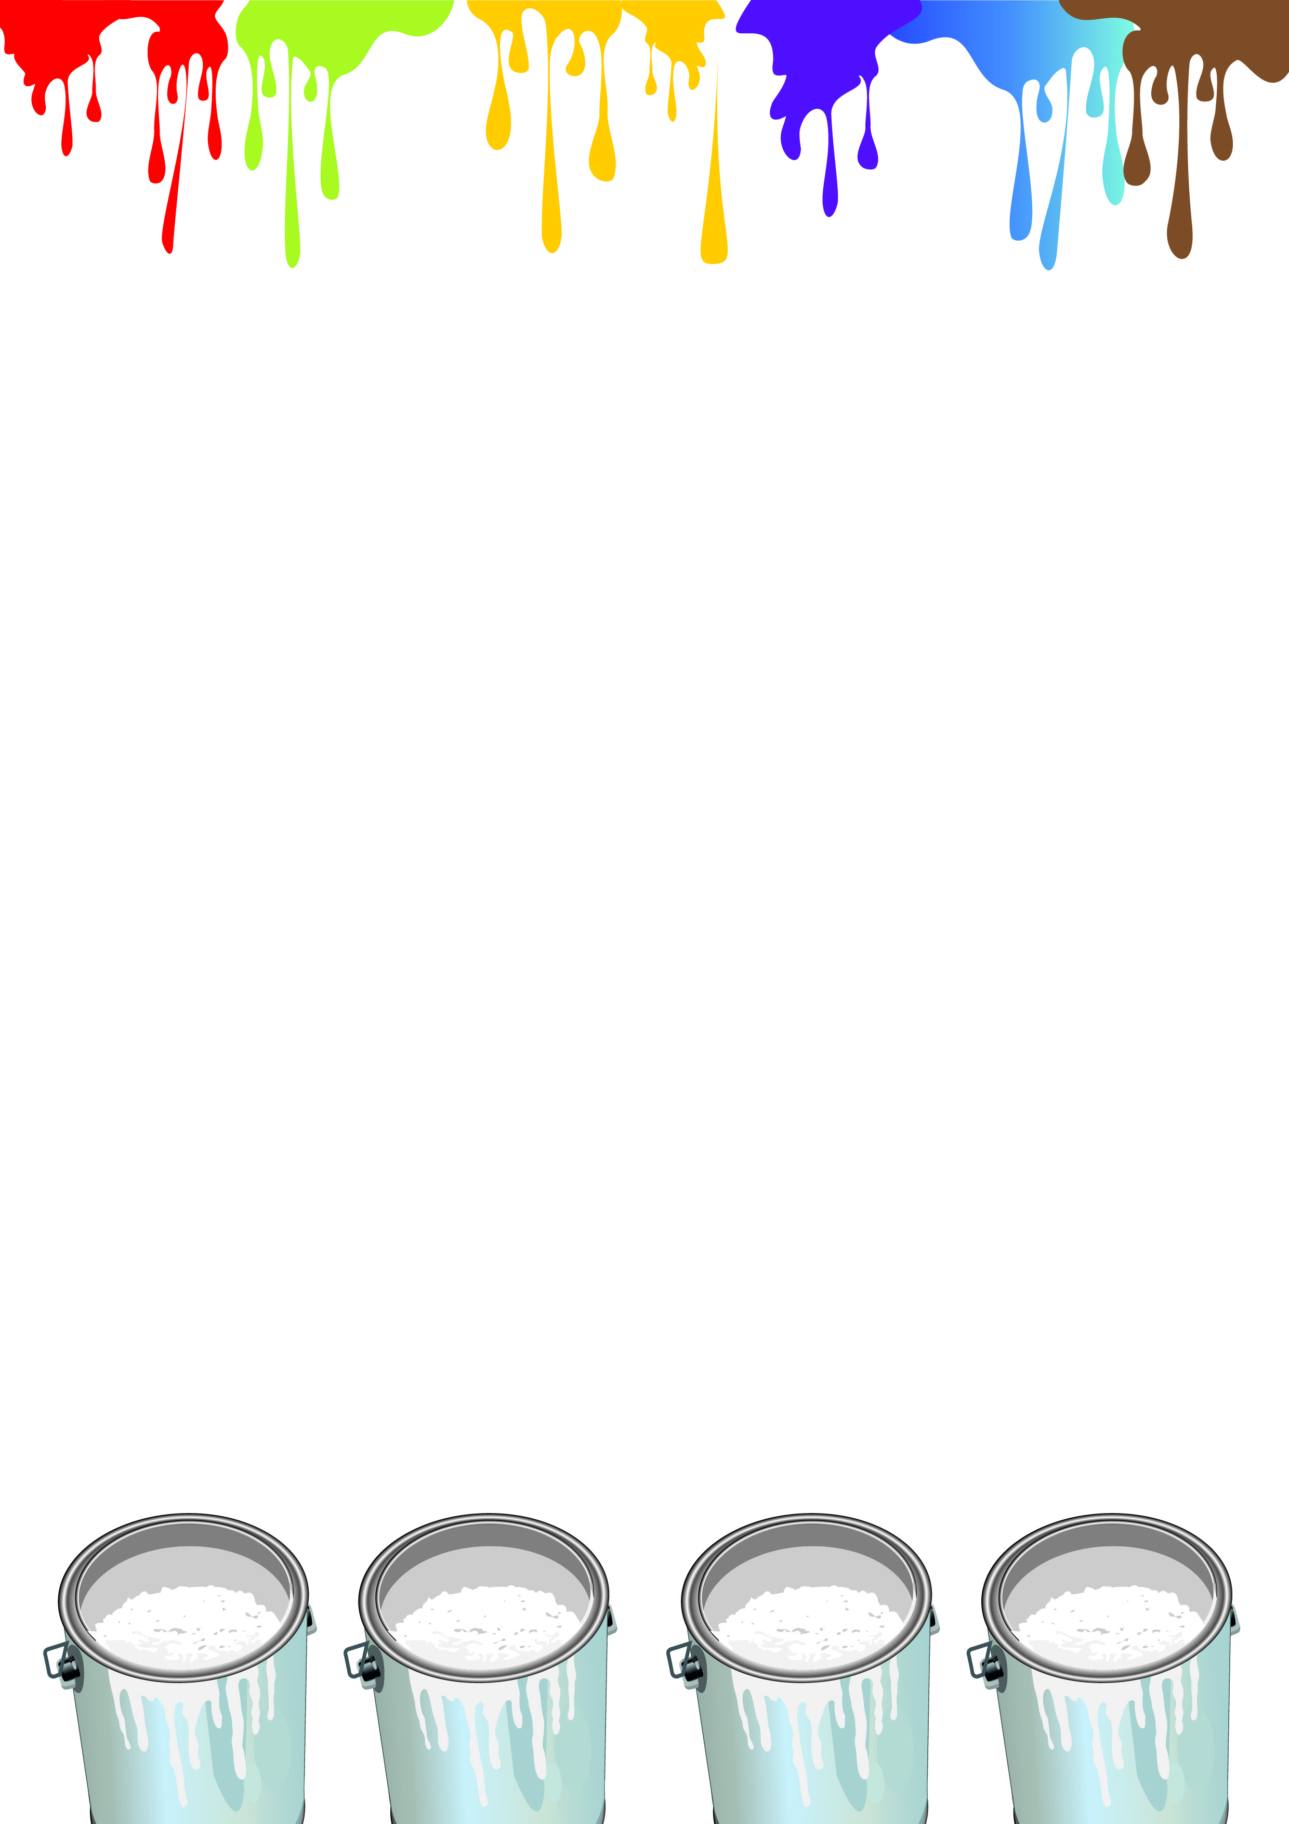

Past Achievements ; Future Endeavours
新社承傳
Creating new house names and colours

- Each house name should include both English and Chinese versions.
- The new house colour can be a single colour or a combination of two colours.
- If it is a single colour, avoid using the existing house colours, i.e. red, blue, yellow, brown, purple and green.
- The colour(s) should be a pure colour. No transparent or gradient colours will be accepted.
- All students and alumni are welcome to participate.
- Entries can be submitted by an individual, group or house.
- The copyright of all submitted entries rests with the school.
- The school has the right to change and refine the designs of all participants, which may be used as the final designs for future house products ( house T-shirts, flags, logo, etc.)
- All entries can be submitted in one of the following formats: (i) hard copy, (ii) JPEG, (iii) PDF or (iv) Word document format.
- Please hand in your work on or before 30 September 2016.

The result will be released in December 2016 on the school webpage and the school notice.

Judges: Mr. Tai Tak Ching
Mrs. Ho Liu Yee Ling
Ms. Wong Yin Lan
Ms. So Wai Yee, Elaine
Ms. Kwok Wai Yin, Winnie
Prizes: School souvenirs and certificates

For enquiry, please contact Mr. Chou Wai Hong or Ms. Kwok Wai Yin, Winnie

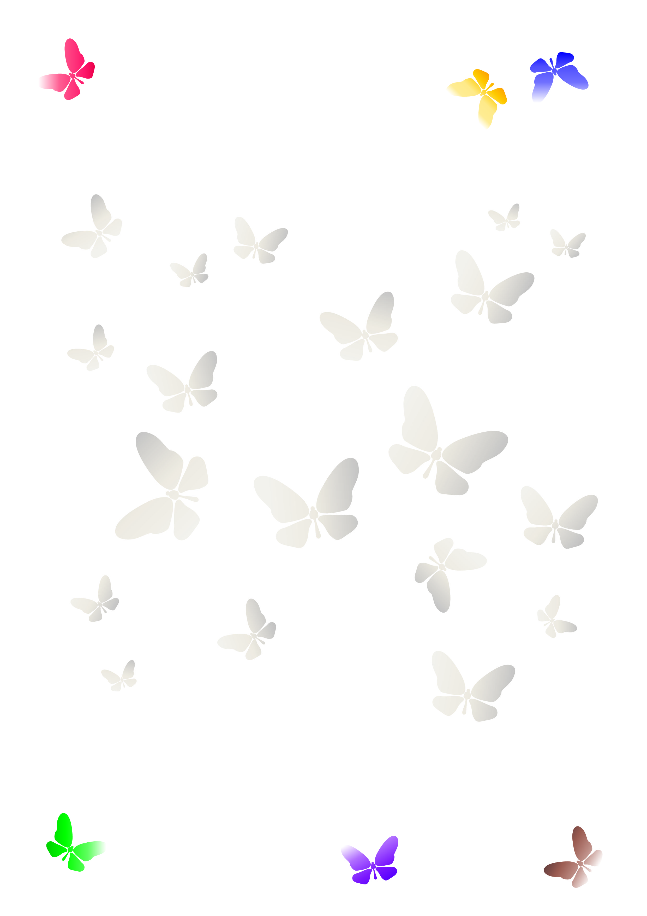
For current student:
Name:_______________
Class:________________
Class number: _________

For alumnus:
Name:______________________
Year of graduated: ____________
Alumnus number (if any):_______
Phone:______________________
Email:_______________________

House 1:
English name:___________________
Chinese name:__________________
Colour/Colours:
Pantone number (if any):__________

House 2:
English name:___________________
Chinese name:__________________
Colour/Colours:
Pantone number (if any):__________

House 3:
English name:___________________
Chinese name:__________________
Colour/Colours:
Pantone number (if have):__________

House 4:
English name:___________________
Chinese name:__________________
Colour/Colours:
Pantone number (if any):__________

